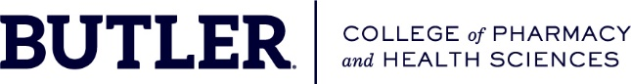

**Our Mission Statement**

Our mission is to provide innovative and interprofessional educational experiences in the health sciences. Connecting with a liberal arts perspective, we develop life-long learners who serve society as dedicated health professionals, scholars, and community leaders.

**Our Vision Statement**

Developing today’s healthcare leaders to overcome tomorrow’s challenges.

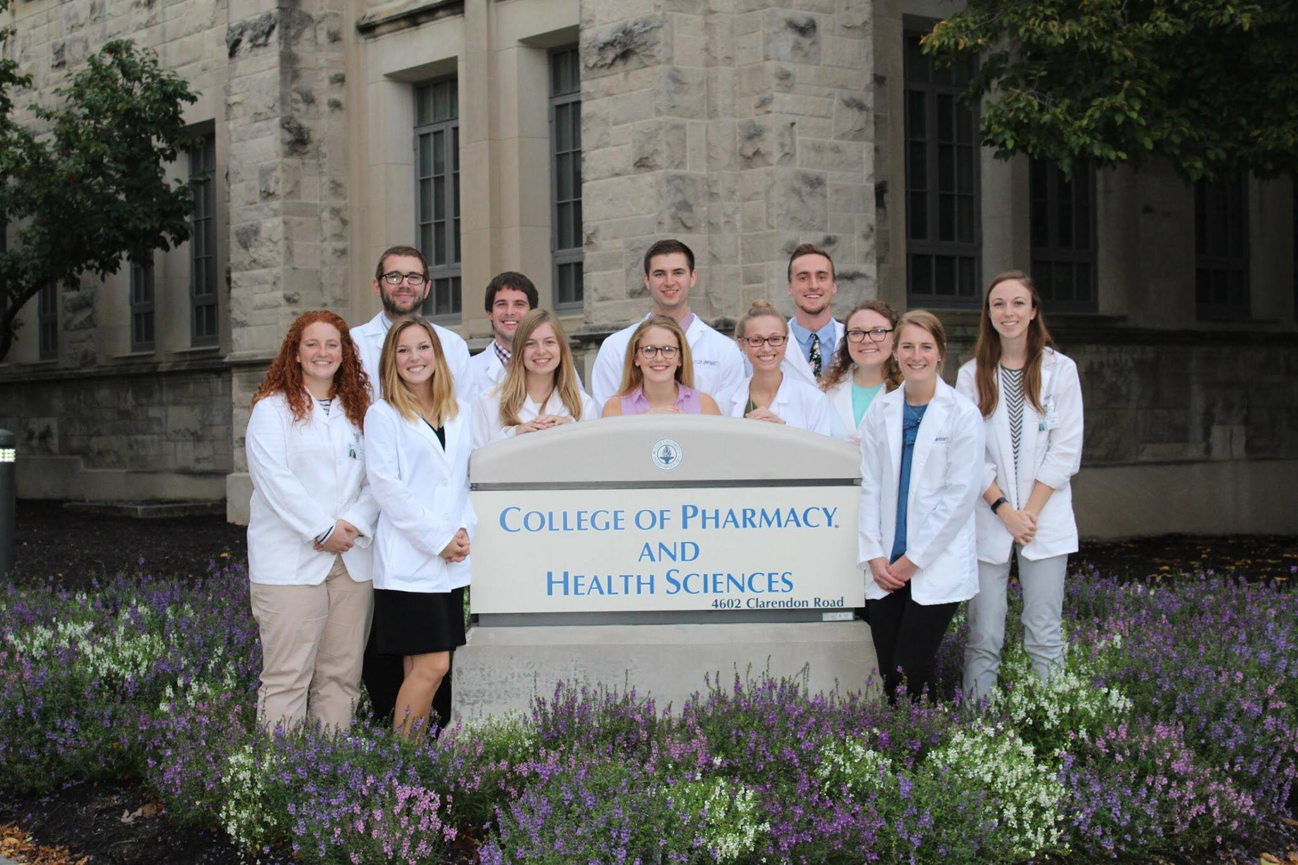

**Butler Pharmacy and ATOM Summer 2021 Summer Internship Program**

**Internship description:**

AI and data science underlie a revolution that is currently underway in the pharmaceutical and healthcare industry. Previously dormant data insights are transforming the long, costly, experimentally-driven drug discovery process into a fast, AI-driven, patient-centric approach.  To accelerate this process, ATOM (<https://atomscience.org/>) is building the work-force of the future – scientists and pharmacologists with integrated expertise in data science, AI, and drug discovery.  Butler University’s College of Pharmacy & Health Sciences, the ATOM consortium, have developed an internship program that will equip professional pharmacy students with data science and machine learning expertise. During a 12-week internship, students will be immersed in the AI-driven drug discovery process remotely with ATOM research mentors. Sitting side-by-side with pharmaceutical industry, data, and machine learning scientists, Butler Pharmacy students will curate and analyze data sets that will be deposited into Drug Target Commons, a crowd-sourcing platform to improve the consensus and use of drug-target interactions. These open data sets also will advance ATOM’s open-source drug discovery platform development. ATOM’s AI-driven platform designs and optimizes drugs *in silico* considering their full pharmacological profile, and incorporates new experimental data, as needed, to advance discovery of new therapeutics.  In addition to cross-training in data science and pharmaceutical domains, interns will develop a repertoire of know-how in computer programming, machine learning, and drug discovery assay development.

**Commitment: ATOM Remote Data Analytics in Drug Discovery Summer Internship**

* 12 Week Commitment:
* Second week of May:  Online Meet and Greet, time to be determined
* Weeks 1 -4: Python Bootcamp with Dr. Caleb Class
* Weeks 3-4: Continue Python Training with Dr. Class; transition to projects with ATOM research mentor
* Weeks 5-12: Work on project with ATOM research mentor; continued training with Dr. Class
* This internship is intended to be a significant 30 to 40 hour weekly commitment.  During weeks 5 through 12, internships are expected to be available Monday through Friday, from 9 am to 5 pm EST. We want to be sure that you realize that this internship is a significant commitment.

**Summary of the Internship of the summer of 2020**

**Pharmacy students dive into data science and AI with ATOM training experience**

Five Butler University Doctor of Pharmacy students received a unique experience in the summer of 2020.

These students delved into the world of data science, artificial intelligence, and machine learning in support of the Accelerating Therapeutics for Opportunities in Medicine (ATOM) consortium.

Through a partnership with the Frederick National Laboratory (FNL), a founding member of ATOM, the Butler PharmD students were each paired with an ATOM mentor and given a project to support ATOM’s machine learning driven drug discovery platform. This innovative and collaborative training opportunity supports ATOM’s mission and helps build a future workforce with integrated expertise in data science, machine learning, and drug discovery—a critical need to transition the pharmaceutical and healthcare industry toward an AI-driven approach.

“AI and data science are transforming what is going on in the pharmaceutical industry,” said Eric Stahlberg, director of Biomedical Informatics and Data Science and ATOM co-lead. “This experience gave the students a sense of what that future will be like.”

The students learned how to **apply** data science **tools** to **analyze** and **prepare** chemical **datasets** for ATOM models. The training experience concluded with a **virtual seminar** on July 24, 2020, in which the students **presented** their **projects** with the ATOM team. The entire 10-week training was completely virtual.

The students had little prior exposure to machine learning. One of the students, Laura Fisher, said she had no prior experience in computer science, but she had welcomed this unique training opportunity to “improve my critical thinking skills and help me gain a deeper understanding of machine learning technology and how it impacts health care.” It was clear from her presentation that she had met this goal as everyone attending the seminar—from ATOM, Butler, and the FNL—lauded all the students’ projects and presentations.

The five students and their projects are described below:

* *Data Curation for a Mitochondrial Membrane Potential Model* by **Paige Cowden**
  + Mentor: Amanda Paulson, FNL
* *Open Data and Model Fitting with AMPL* by **Laura Fischer**
  + Mentor: Hiran Ranganathan, Lawrence Livermore National Laboratory (LLNL)
* *Working with Open Datasets* by **Connor Reyd Miller**
  + Mentors: Yaru Fan, LLNL, and Ben Madej, FNL
* *Visualize Data: A Python Function to Generate Interactive Plots and Accelerate Exploratory Data Analysis* by **Logan Van Ravenswaay**
  + Mentor: Ben Madej, FNL
* *Open Cancer and Infectious Disease Datasets* by **Chris Zeheralis**
  + Mentor: George Zaki, FNL (with support from Ravi Ravichandran, FNL)

The trainees worked with publicly available data, applying their new computer science skills and existing pharmaceutical knowledge to characterize and curate the datasets. Curated datasets are critical for fitting predictive machine learning models for applications such as virtual screening and lead optimization with the ATOM platform.

Or as Connor Miller succinctly stated during his presentation, “More data equals better models.”

“This program reflects the trend that data science approaches are spreading across industries from pharmaceutical research and development to the healthcare industry,” stated a data scientist with FNL and ATOM. “The experiences the interns have had at ATOM will certainly transfer beyond their summer projects.”

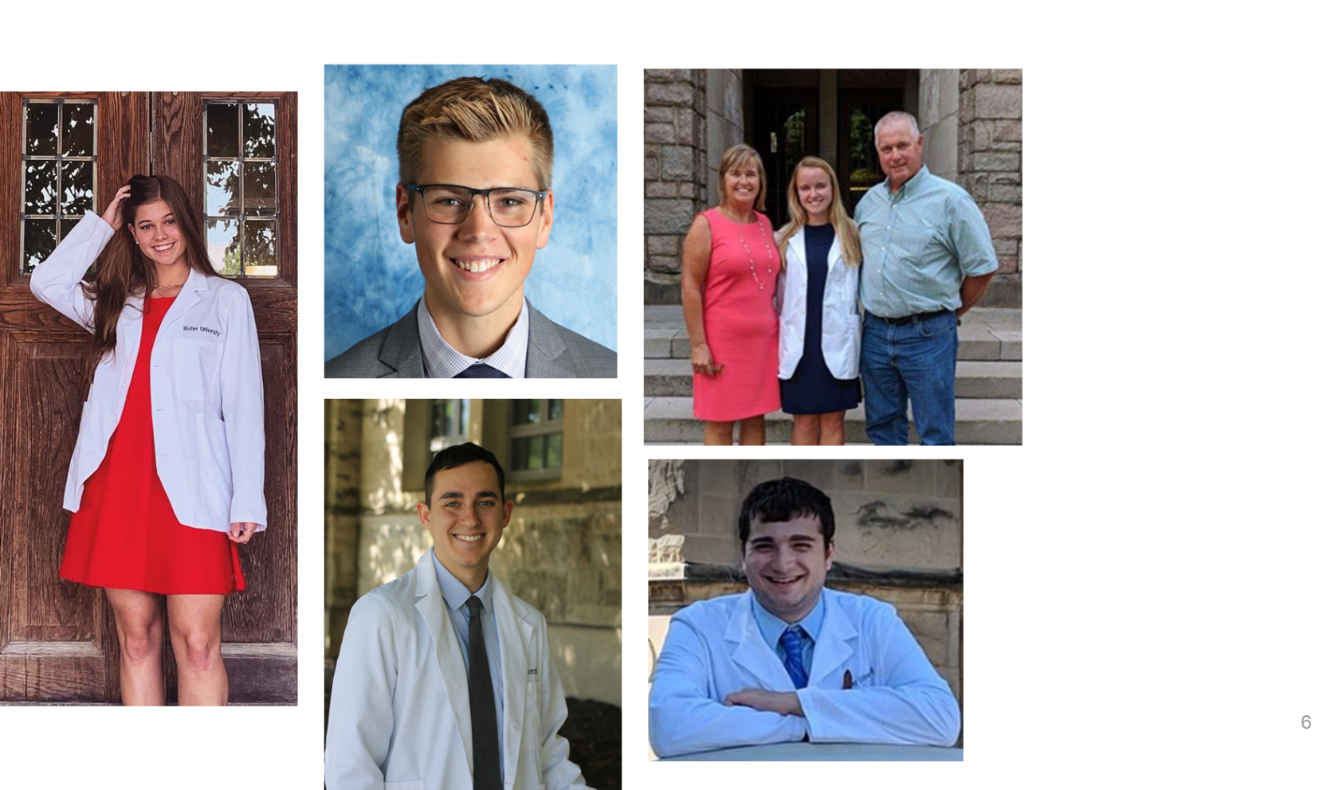

Photo 1: (clockwise) ATOM trainees: Paige Cowden, Logan Van Ravenswaay, Laura Fischer, Chris Zeheralis, and Connor Miller

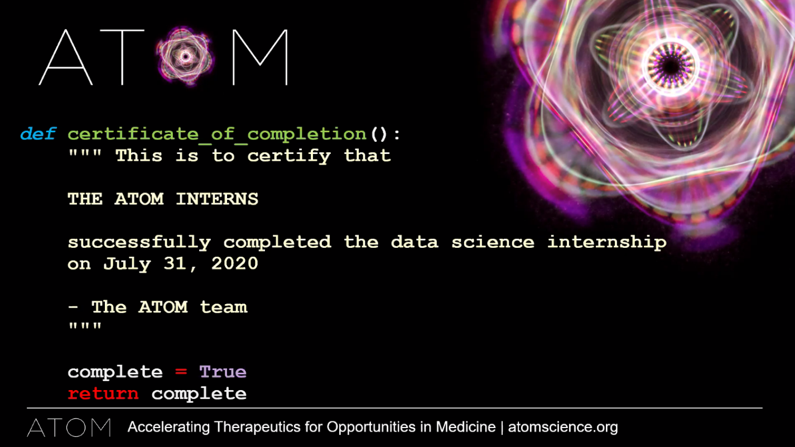Photo 2: Ben Madej wrote the certificate of completion in Python code.